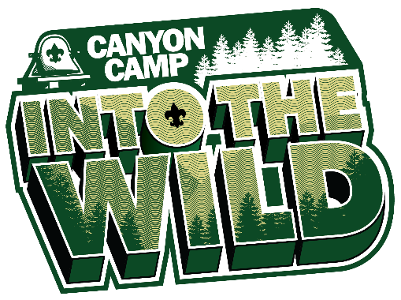
2022 CANYON CAMP WEBELOS/AOL WEEKEND (7/29-7/31)
DAILY SCHEDULE

Webelos ‘Adventures’ Earned: Aquanaut, Build It, Castaway, Earth Rocks, Game Design

FRIDAY
5:00-8:00 Check-In
5:30-8:00 Open Swim at Pool / Trading Post Open
8:00-8:30 Parent Meeting / COPE Games with Staff
8:45 Opening Campfire in the Pratt Dance Ring
10:00 Lights Out
SATURDAY
7:15 Wake-up
7:45 Flag Raising At the Flagpole
8:00 Breakfast in Dining Hall
9:00 Program Session 1
10:00 Program Session 2
11:00 Program Session 3
12:15 Lunch in Dining Hall
2:00 Program Session 4
3:00 Program Session 5
4:00 Program Session 6
5:45 Flag Lowering At the Parade Field
6:00 Dinner in Dining Hall
7:00 Program Session 7
8:00-8:30 Christian Non-Denominational Service
8:30-9:30 Moonlight Swim / Trading Post Open
10:00 Lights Out
SUNDAY
7:15 Wake-up
7:45 Flag Raising At the Flagpole
8:00 Breakfast in Dining Hall / Catholic Mass in Stockton (Leave at 7:30)
9:00 Program Session 8
10:00 Program Session 9
11:00 Closing Ceremony At Coon Rock

 | Group 1 | Group 2 | Group 3 | Group 4 | Group 5 | Group 6
Session 1 | Pool | Games | Scoutcraft | Archery | Climbing | BB Guns
Session 2 | Pool | Pool | Games | Scoutcraft | Archery | Climbing
Session 3 | Handicraft | Pool | Pool | Games | Scoutcraft | Archery
Session 4 | Nature | Handicraft | Pool | Pool | Games | Scoutcraft
Session 5 | BB Guns | Nature | Handicraft | Pool | Pool | Games
Session 6 | Climbing | BB Guns | Nature | Handicraft | Pool | Pool
Session 7 | Archery | Climbing | BB Guns | Nature | Handicraft | Pool
Session 8 | Scoutcraft | Archery | Climbing | BB Guns | Nature | Handicraft
Session 9 | Games | Scoutcraft | Archery | Climbing | BB Guns | Nature

